Project Report

Random 8 Puzzles Game

MAX TECH COMPUTER INSTITUTE



Project Supervisor

Mr. Ihsan Ullah

MAX TECH COMPUTER Institute
Near Agriculture Bank College Colony Saidu Sharif Swat
Phone No. 0946-729716, Mob: 03469470741

Ref: _____________ Dated_____________

CERTIFICATE

This is to certify that Mr. Bilal Hussain (R.No.300556) and Mr. Amjad Ali (R.No.300552) have worked on and completed their Software Project of Details Marks Certificate Calculator in Java Script, HTML, for Making the Details marks Certificates for school systems for fulfillment of the requirement for the Diploma in Information Technology (One Year) under my guidance and supervision.

In our opinion, their project is satisfactory and up to the mark and therefore fulfills the requirements of DIT.

Mr. Ihsan Ullah
Supervisor,
Software Projects & Research Section,
Max Tech Computer Institute, Swat.

___________________
(Signature)

Accepted By:

_____________
(For office use)

EXORDIUM

In the name of Allah, the Compassionate, the Merciful.

Praise be to Allah, Lord of Creation,
The Compassionate, the Merciful,
King of Judgment-day!

You alone we worship, and to You alone we pray for help,
Guide us to the straight path

The path of those who You have favored,

Not of those who have incurred Your wrath,
Nor of those who have gone astray.

DEDICATION

We dedicated this effort to our teachers who give us awareness about the modern technology and enabled us to become technology experts and program developer in very less time. May Allah bless them.

ACKNOWLEDGEMENT

We would like to acknowledge the efforts of our Teachers, Instructors and all the team associates to Max Tech Computer Institute especially to our project supervisor, whose efforts made us eligible to complete this challengeable task successfully and ardently.

We will always remember the guidance and support of all our efficient and hardworking teachers. We can say that they not only passed the time but they provide us the real knowledge and technology, which will beneficial for us in every walk of life.

We are thankful to all the team of Max Tech Computer Institute.

PREFACE

Welcome to the project proposal for the development of a Random 8 Puzzle Game in HTML. This document outlines the plan to create an interactive web-based game that challenges users to solve randomized 8 Puzzle configurations. By combining HTML, CSS, and JavaScript, this project aims to provide an engaging gaming experience that tests users' problem-solving skills and offers hours of entertainment. The following sections detail the objectives, features, and implementation plan for this exciting endeavor.

INTRODUCTION

The Random 8 Puzzle Game project aims to develop a web-based game inspired by the classic 8 Puzzle concept. In this game, users will be presented with a grid of tiles, initially arranged in a random configuration. The objective is to rearrange the tiles into a specific pattern by sliding them horizontally or vertically. The game will feature interactive elements and feedback to guide users through the puzzle-solving process.

PURPOSE
The purpose of this project is to create an entertaining and challenging game that showcases the capabilities of HTML, CSS, and JavaScript in web development. By implementing features such as random puzzle generation, interactive tile movements, and validation, the project aims to provide users with an immersive gaming experience. Additionally, the project serves as a learning opportunity to explore game development techniques and enhance programming skills. Intended users of this document are:
- Software developer, who will use this document as reference while designing and coding the system
- The project manager, who will need this document to monitor and track the progress of the project if needed, change the project scope by modifying this document through the change control process.
- Other member of project team who will need this document.

SCOPE:
The scope of the project encompasses the development of a complete web-based 8 Puzzle game, including the following key features:

- Random generation of initial puzzle configurations.
- Interactive interface allowing users to move puzzle tiles by clicking on them.
- Validation of user moves to determine puzzle completion.
- Timer functionality to track user completion time.
- Display of congratulatory messages upon successful puzzle solving.
- The project will focus on implementing these features within the constraints of HTML, CSS, and JavaScript, targeting compatibility across different browsers and devices.

OVERVIEW

The project proposal provides a comprehensive plan for the development of the Random 8 Puzzle Game. It outlines the objectives, features, technology stack, implementation plan, challenges, testing approach, future enhancements, and references. The proposal aims to establish a clear understanding of the project goals and methodologies to guide the development process effectively.

Figures:

The following figures show the random puzzles and figure of completion of the game.

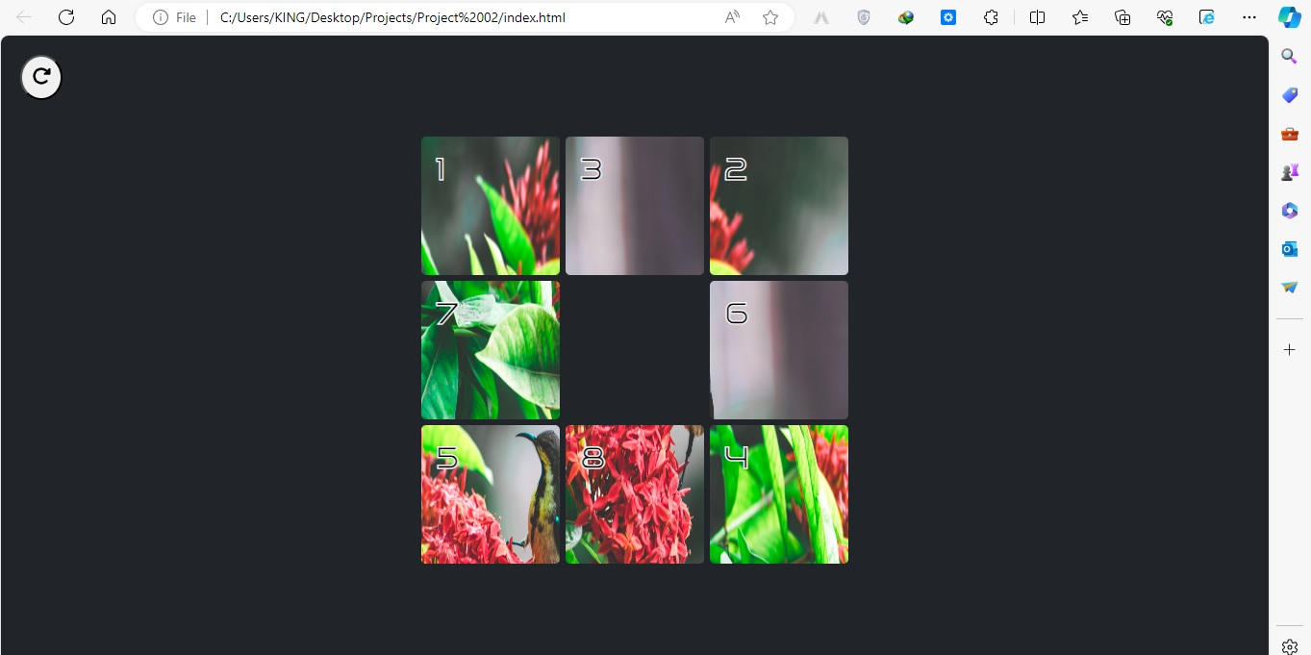

Figure 1.1

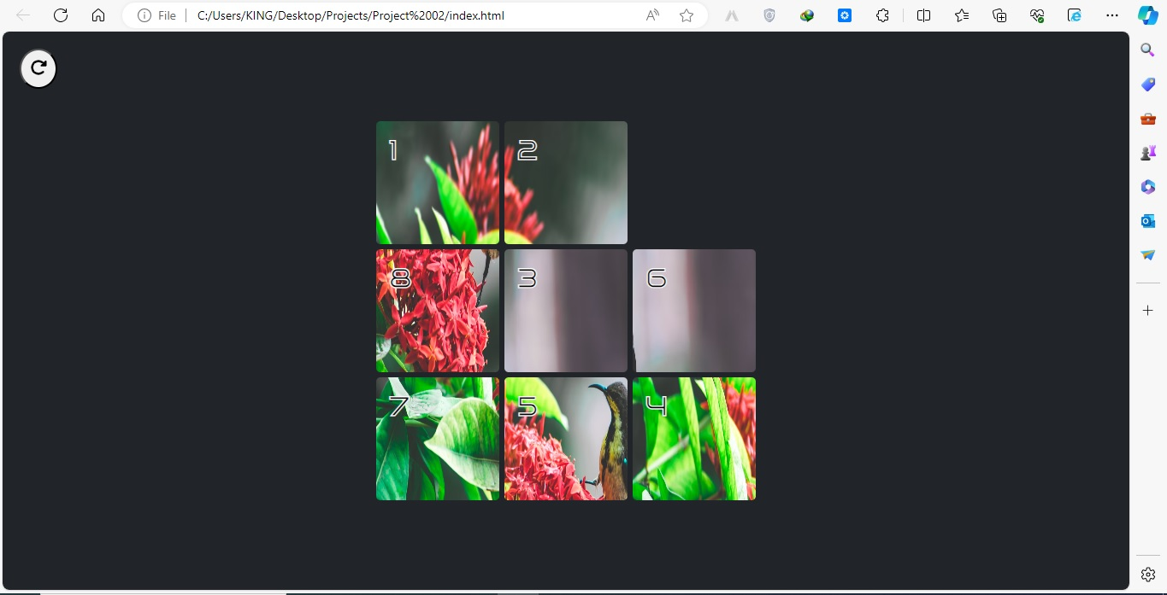

Figure 1.2

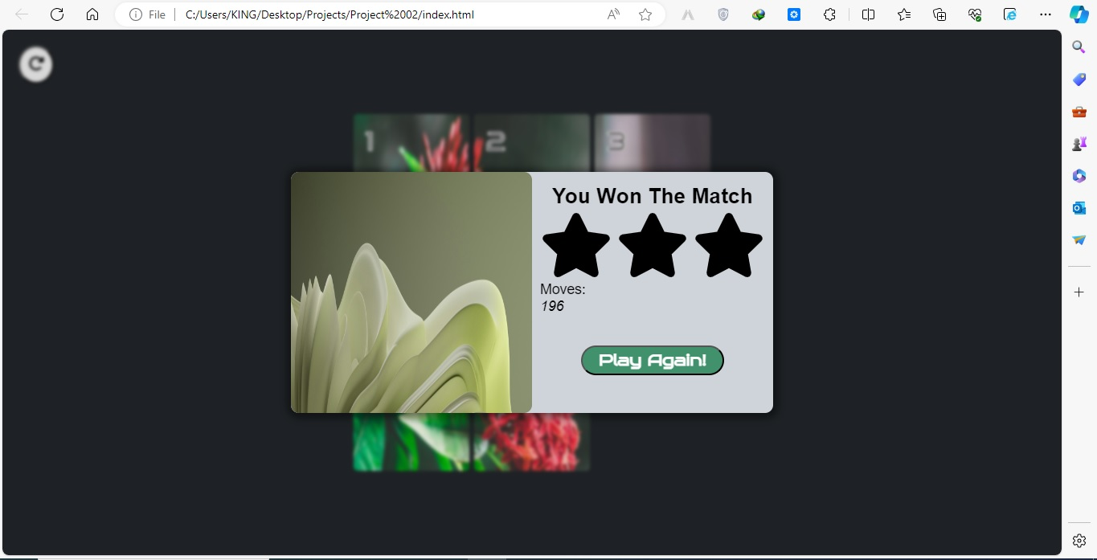

Figure 1.3

THE END

